Linear Search
Linear search is a sequential search algorithm in which we start from one end and check every element of the list until the desired element is found. It is the simplest search algorithm.

How Linear Search Works?
The following steps are taken to search for the element k = 1 in the list below.
Array to be searched for
- Start from the first element, compare k with each element x.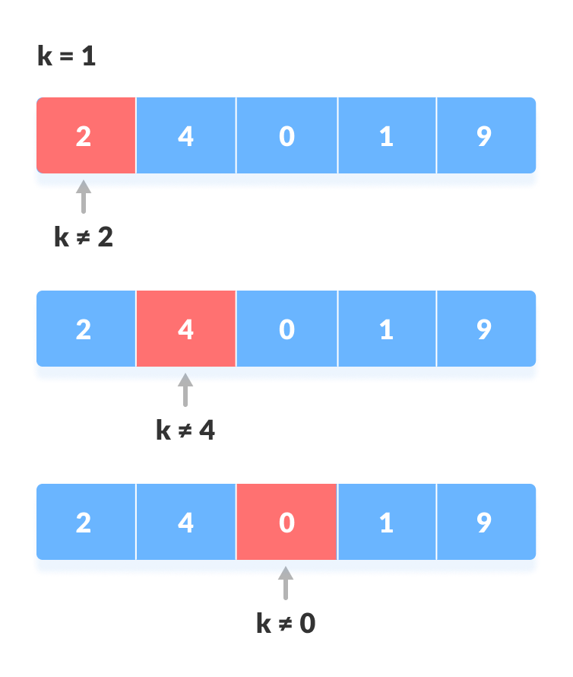Compare with each element
- If x == k, return the index.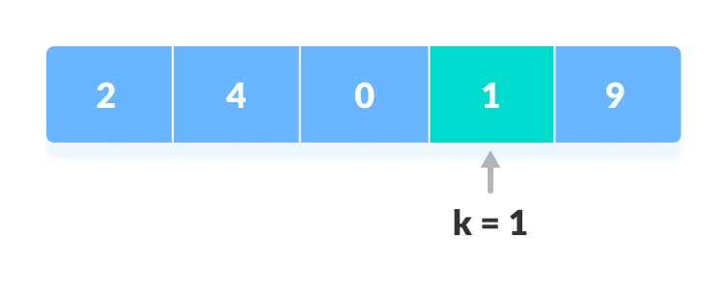Element found
- Else, return not found.

Linear Search Algorithm
LinearSearch(array, key)
for each item in the array
if item == value
return its index

Java

class LinearSearch {
public static int linearSearch(int array[], int x) {
int n = array.length;

// Going through array sequencially
for (int i = 0; i < n; i++) {
if (array[i] == x)
return i;
}
return -1;
}

public static void main(String args[]) {
int array[] = { 2, 4, 0, 1, 9 };
int x = 1;

int result = linearSearch(array, x);

if (result == -1)
System.out.print("Element not found");
else
System.out.print("Element found at index: " + result);
}
}

Linear Search Complexities
Time Complexity: O(n)
Space Complexity: O(1)

Linear Search Applications
- For searching operations in smaller arrays (<100 items).

